--------------------------------------------**Troubleshooting methods--------------------------**

==============================================================================

1. **When Durby error come while ruuning admin server:=**

Soloutions   
for derby server errors.  
------------------------------------------------------------------------------------------------------  
soloution-1

D:\app\Oracle\config\domains\ess\servers\AdminServer\data\ldap\conf

**rename file replicas.prop as replicas_old.prop**------------------------------------------------------------------------------------------------------  
soloution-2

**adaptor_ohs.xml replace**

**(Copy from** D:\app\Oracle\product\12.2.4\oracle_common\modules\oracle.ovd\templates

**to**

D:\app\Oracle\config\domains\ess\config\fmwconfig\ovd\default**)**  
-----------------------------------------------------------------------------------------------------  
soloution-3

D:\app\Oracle\config\domains\ess\servers\AdminServer\tmp

**rename AdminServer.lok file as AdminServer_old.lok**

1. **When show job running fine but report not hits at showjob.**

• Replace the rwnetwork.conf file with a working version from another properly functioning server.

• Verify key installation/configuration files:

* default.env
* reserver.conf

• If any of these files are blank or incorrectly configured:

Take a **backup** of the existing files.

Replace them with working copies from other server.

1. **When report server (WLS_REPORT)not running :=**

* The report server service is not starting or responding.

**Solution:**

1. Navigate to:  
   D:\app\Oracle\config\domains\ess\servers\WLS_REPORTS  
   Take a **backup** of the following folders:
   * tmp
   * cache
   * data
2. After backing up, **delete** the above folders .
3. Review and reconfigure the following:
   * Rwreportserver
   * Rwservlet.properties

**2) Form Server(WLS_FORMS) Not Running**

**Solution:**

1. Navigate to:  
   D:\app\Oracle\config\domains\ess\servers\WLS_FORMS  
   *(Or equivalent path: /app/oracle/domains/base_domain/servers/WLS_FORMS)*
2. Take a **backup** of the following folders:
   * cache
   * tmp
   * data
3. **Delete** the contents of these folders:
   * D:\app\Oracle\config\domains\ess\servers\WLS_FORMS\tmp
4. **Restart** the WLS_FORMS service.
5. Reconfigure:
   * formsweb.cfg
   * default.env
6. **when below type of message(FOLDER ACCESS DENIED) show while running report or invoice at POS:=**

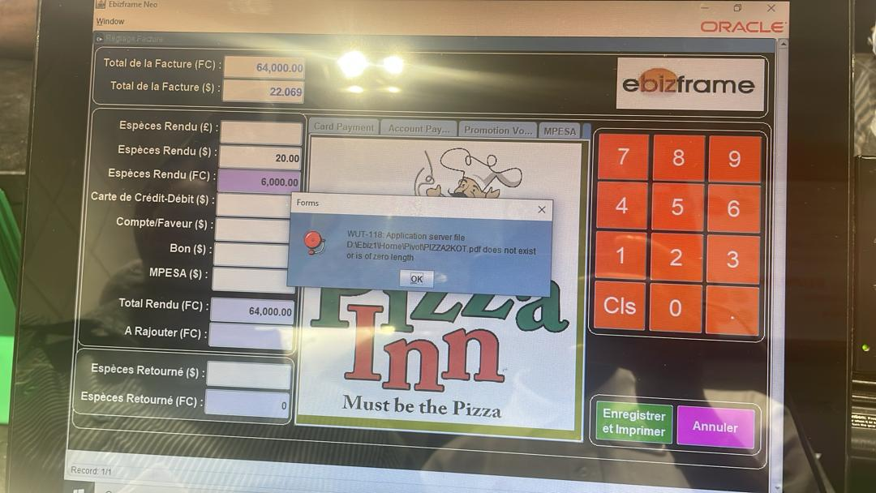

**Solution :**

* + 1. **In rwserver.conf file missing of write access**

<folderaccess>

<write>…..path …………</write>

</folderaccess>

• Copy the <folderaccess> section into your local rwserver.conf, making sure the <write> path matches the directory.

• Save and restart the report server to apply the changes.

* + 1. Check inv.prt file exist or not .

(D:app/oracle/12.1.2/java/reports/printers)

If not exist put by taking form others server

.